

# Institution Details

|  |  |  |  |
| --- | --- | --- | --- |
| **Province** | Sindh | **City** | Karachi |
| **Institution** | National University of Computer and Emerging Sciences (FAST-  NU) | **Campus** | Karachi |
| **Department** | School of Computing | **Degree Level** | BS |
| **Degree Program** | Software Engineering/Cyber Security | **Telephone** |  |
| **Fax** |  | | |

Supervisor Details



|  |  |  |  |
| --- | --- | --- | --- |
| **Name** | Mr. Abuzar Zafar | **Gender** | Male |
| **Mobile** | +92 330 2130927 | **Office No** | 136 |
| **Email** | [Abuzar.zafar@nu.edu.pk](mailto:Abuzar.zafar@nu.edu.pk) | **Designation** | Lecturer |
| **Qualification** |  | | |

# Co-Supervisor Details

|  |  |  |  |
| --- | --- | --- | --- |
| **Name** | Mr. Ali Shah Fatmi | **Gender** | Male |
| **Mobile** | +92 342 2598253 | **Office No** | N/A |
| **Email** | [Ali.fatm](mailto:Ali.fatmi@nu.edu.pk)[i@nu.edu.pk](mailto:i@nu.edu.pk) | **Designation** | Lecturer |
| **Qualification** | N/A | | |

Head of Department Details

|  |  |  |  |
| --- | --- | --- | --- |
| **Name** | Dr. Atif Tahir | **Mobile No.** | - N/A |
| **Email** | [atif.tahir@nu.edu.pk](mailto:atif.tahir@nu.edu.pk) | **Gender** | Male |

# Project Details

|  |  |  |  |  |  |
| --- | --- | --- | --- | --- | --- |
| **Project Title** | Blood Safe Life | | | | |
| **Group Details** | **Member 1 Name: Zeeshan Mustafa Member 1 Roll#:21K-3919** | | **Member 2 Name: Abbas Fazel Member 2 Roll#:21K-3592** | | **Member 3 Name: M.Musayiab Member 3 Roll#:21K-4760** |
|  | | | | |
| **Project Area of** | Cyber Security, Web Programming, Artificial Intelligence | | | | |
| **Specialization** |
| **Project Start** | As per FYP calendar | **Project End Date** | | As per FYP calendar | |
| **Date** |

Project Summary

The Blood Safe LIFE project aims to transform blood donation management and access in Pakistan, addressing the ongoing challenge of meeting blood demand due to chronic conditions like β-Thalassemia Major and high rates of accidents, pregnancies, and diseases such as dengue and cancer. Despite the high demand, Pakistan faces a critical shortage of regular blood donors, with only 10.6% of the population participating voluntarily. Myths and misconceptions about blood donation, including fears of health risks and concerns about misuse, further discourage participation.

To tackle these issues, Blood Safe LIFE provides a comprehensive digital platform that ensures a safe, secure, and convenient donation process for both donors and recipients. The platform features secure registration, privacy protection for personal and medical data, and encourages the creation of family-based donor networks for emergency situations. Real-time coordination between donors, hospitals, and blood banks is a key feature, simplifying the process of finding and accessing nearby facilities.

Security and privacy are top priorities for the platform, with advanced measures in place to protect donor information and build user trust. Blood Safe LIFE aims to bridge the gap between the growing demand for blood and the limited supply while fostering a culture of voluntary donation in Pakistan. By offering a secure, accessible, and community-driven solution, the project seeks to make a significant impact on the country's healthcare system, saving lives by ensuring blood availability when needed most.

# Project Objectives

The **Blood Safe LIFE** project is designed to revolutionize the blood donation and transfusion system in Pakistan by addressing several critical issues. Following are the key objectives of **Blood Safe LIFE** that is discussed below:

### Facilitate Blood Donation and Redemption

The primary objective of the platform is to simplify the process of donating blood and redeeming it when needed. Users will be able to donate blood and, in return, receive a form of "credit" that they or their family members can redeem in the future, should they require blood.

### Enable Secure Blood Transfer Between Users with Consent

The platform will also feature a secure mechanism for transferring donated blood from one user to another with mutual consent. In cases where a donor wishes to allocate their donated blood to a specific individual (such as a friend or family member)

### Real-Time Blood Requests and Notifications to Users

One of the major challenges in blood donation is the lack of timely access to donors during emergencies. To address this, **Blood Safe LIFE** will enable users to request blood in real time, immediately notifying all potential donors through the platform’s app. Upon receiving a request, nearby donors will be alerted, allowing them to respond quickly if they are available to donate.

### 3. Blood Requests and Exchange Program

When a user submits a blood request with all relevant details, nearby donors are notified. Instead of going directly to the patient's hospital, the donors are directed to the nearest certified blood bank to donate. Upon donation, the requestor receives a notification to collect the blood from that blood bank.

If the donor's blood group is different from the patient's, the blood bank can facilitate an exchange, providing the required blood type from their stock if available. The donor still receives a "bottle credit" for their contribution, encouraging future donations.

### Track Donated Blood Usage While Preserving Privacy

Transparency in the blood donation process is crucial to building trust among donors. The platform will allow donors to track the journey of their donated blood—from the moment it is collected, processed, and sent to a medical facility, to when it is ultimately used by a recipient. This tracking feature is designed to give donors peace of mind, knowing their contribution has gone to someone in need.

### Incentivize Loyal Donors with Rewards and Appreciation

Encouraging regular blood donations is critical to maintaining a stable and reliable blood supply. **Blood Safe LIFE** will implement an incentive program designed to reward loyal and frequent donors.

### Provide Requesters with Real-Time Blood Location Information

For individuals seeking blood, especially during emergencies, knowing where the required blood is available can be life-saving. The platform will offer real-time information on the availability and location of blood units across various hospitals and blood banks.

### Awareness and Education About Blood Donation

An essential component of **Blood Safe LIFE** is addressing the significant lack of awareness about the importance of blood donation

# Literature/ Background Study

In developing our web-based blood bank system, it is essential to understand the operations and features of existing organizations in the field. Here are some notable examples:

* + **Shaukat Khanum Memorial Cancer Hospital & Research Centre (SKMCH&RC) Blood Bank**
    - **Functions**:
* **Credit of Blood & Redemption**: Tracks blood donations and manages redemption processes for patients in need, ensuring that donors' contributions are recorded and utilized effectively.
* **Upcoming Donation Notification**: Alerts the community about scheduled blood donation drives and events to maintain a steady supply of blood for cancer patients.
  + - **Website**: [SKMCH&RC Blood Bank](https://www.shaukatkhanum.org.pk/)

## Pakistan Red Crescent Society (PRCS) Regional Blood Donor Centre (RBDC)

* **Vision**: To inspire responsibility, compassion, and unity in society, setting new standards in blood banking and healthcare.
* **Mission**: To save lives through voluntary, unpaid blood donation and to create a seamless connection between donors and patients.

### Functions:

* + **Credit of Blood & Redemption**: Maintains records of blood donations and allows for blood redemption by registered individuals or organizations.
  + **Upcoming Donation Notification**: Provides notifications and reminders about upcoming blood donation drives to encourage community participation.
* **Website**: PRCS RBDC

## Indus Hospital Blood Bank

* + - **Functions**:
      * **Credit of Blood & Redemption**: Offers a system to credit blood donations to donor accounts and facilitate the redemption of blood when required by patients.
      * **Upcoming Donation Notification**: Sends notifications to registered donors about upcoming blood donation events and drives.

o **Website**: [Indus Hospital Blood Bank](https://www.indushospital.org.pk/)

## St. Theresa’s Blood Centre

* **Mission**: To be the leading blood centre serving hospitals, Thalassemia patients, and underserved communities in Telangana and Andhra Pradesh.

## Key Functions:

* + Blood Banking and Donation
  + Blood Donation Awareness Programs
  + Blood Transfusion
  + Free Diagnostic and Medical Camps
  + 24/7 Blood Bank Services
  + Blood Storage and Preservation
* **Website**: St. Theresa’s Blood Centre

## Institute of Blood Transfusion

* **Key Functions**:
  + Registration of blood donors and management of blood units
  + Screening blood for transfusion-transmissible infections (TTIs) such as HIV, Hepatitis B and C, Malaria, and Syphilis
  + Monitoring and surveillance of blood units
* **Website**: Institute of Blood Transfusion

## Blood Bank of America

* + - **Functions**: Manages a comprehensive database for blood donors, offers online appointment scheduling, and sends notifications for upcoming blood donation drives. Provides detailed information and resources to facilitate donor engagement.
    - **Vision**: To be a leader in blood donation services by offering accessible and efficient solutions for both donors and patients.
    - **Mission**: To ensure a steady and reliable supply of blood by leveraging technology and community involvement to meet the needs of healthcare providers.
      * **Website**: Blood Bank of America

## Red Cross Blood Services

* + - **Functions**: Provides family registration, allows online appointment scheduling, and sends reminders for upcoming blood donation events. Focuses on streamlining the donation process and enhancing donor convenience.
    - **Vision**: To be the most trusted and innovative blood services organization, setting the standard for quality and efficiency in blood donation.
    - **Mission**: To save lives through the provision of safe and sufficient blood supplies by engaging with donors and communities to maintain a reliable blood reserve.

o **Website**: Red Cross Blood Services

## NHS Blood and Transplant

* + - **Functions**: Offers family registration and appointment scheduling through an intuitive online portal, along with notifications for upcoming blood donation campaigns. Focuses on efficient blood collection and distribution.
    - **Vision**: To be a world leader in blood and organ donation services, recognized for excellence in healthcare and patient outcomes.
    - **Mission**: To provide life-saving blood and transplant services with the highest standards of safety and care, driven by donor commitment and innovation.

o **Website**: [NHS Blood and Transplant](https://www.nhsbt.nhs.uk/)

# Project Implementation Method:

The implementation of Blood Safe Life will follow a modular, agile approach. The core functionalities will be developed for three key user roles: Donor, Blood Bank Admin, and System Administrator.

The **Donor** role will provide features such as registration, donation tracking, blood bottle balance management, and real-time AI-driven notifications. The **Blood Bank Admin** will manage blood requests, process redemptions based on donor balance, and upload donor blood reports. The **System Administrator** will oversee system maintenance, user management, and monitor dashboards for analytics and performance insights.

The **frontend** will be built using **React.js** for an intuitive, responsive interface, while the **backend** will rely on **Node.js** and **Express.js** to efficiently manage server-side operations. **MongoDB** will serve as the database, securely storing donor data, donation history, and blood balances.

**Secure Platform:** For our web-based blood bank system, ensuring the highest level of security for sensitive medical and personal information is crucial. We will adhere to **ISO/IEC 27001** to implement a robust information security framework tailored to protect donor and recipient data. An **Intrusion Detection System (IDS)** will be employed to monitor and detect potential threats in real-time. Data will be secured through **encryption**, both in transit and at rest, to protect against unauthorized access. **Anonymization techniques** will be used to safeguard personal data and ensure compliance with privacy regulations. Comprehensive **penetration testing** will be conducted at the end of the project to identify and address any vulnerabilities, ensuring the platform remains secure and reliable for all users. These measures are essential for maintaining the integrity and confidentiality of the blood bank's operations..

**Real-time analytics dashboards** will provide insights into blood request trends, donor activity, and timeframe analysis, optimizing the system's performance. **Timeframe analysis** will track minimum, maximum, and average response times for blood requests and donations, ensuring an efficient process.

Donors can also track where their blood is used, fostering transparency and trust. Incentives, such as loyalty benefits and extended redemption timeframes, will encourage regular donations and reward loyal users.

Overall, **Blood Safe Life** offers a seamless, AI-powered platform that streamlines blood donation processes, enhancing efficiency, transparency, and trust in the healthcare system.

# Benefits of The Project:

The **Blood Safe LIFE** project introduces a transformative approach to how blood donations and transfusions are managed, addressing several critical challenges in the current system. This project not only improves the efficiency of blood donation and distribution but also significantly enhances donor participation, transparency, and safety. Below are the key benefits of the project and how it will positively impact the existing blood donation system:

1. A real-time notification that offers an immediate connection between donors and recipients.
2. A full transparency platform where the donor can track their Blood journey from donation to transfusion.
3. Health benefits test and Gifts as an incentive to encourage regular donor.
4. Real-time data on blood availability helps requesters quickly find compatible blood units.
5. Educational resources and campaigns address public misconceptions about blood donation.
6. Strong privacy and security measures protect donor and recipient information.
7. The blood redemption feature empowers donors to redeem units for themselves or their families.
8. Seamless integration with blood banks and hospitals ensures real-time data accuracy.
9. It builds a sustainable blood donation network by fostering a community of regular donors.
10. The platform serves as a model for future blood donation systems, inspiring healthcare innovations.

# Technical Deliverables:

### Frontend Development:

* A user-friendly interface built using **React.js**, ensuring responsiveness and ease of navigation across all user roles (Donor, Blood Bank Admin, System Administrator).
* Key features include donor registration, donation tracking, blood bottle balance management, real-time notifications, and report access.

### Backend Development:

* A scalable and secure backend using **Node.js** and **Express.js** to handle user requests, business logic, and real-time processing.
* Integration of **MongoDB** for database management to store donor details, donation history, blood balances, and system logs.
* **API integration** for AI-driven functionalities such as fraud detection, health assessments, and blood demand prediction.

### Secure Authentication:

* Implementation of **OAuth** for secure third-party logins (Google, Facebook), with **JWT** for session management and authorization.
* Role-based access control (RBAC) to ensure secure and proper access for Donors, Blood Bank Admins, and System Administrators.
* **Multi-Factor Authentication (MFA)**: Require MFA for additional security, verifying user identities through multiple methods (e.g., password plus a one-time code).

### Maintain Privacy:

* **Data Encryption:** Encrypt all sensitive donor data, including health records and donation details, both during transmission and while stored to prevent unauthorized access.
* **Anonymization Techniques**: Apply anonymization methods to obscure personal information, ensuring that data used for processing and analysis cannot identify individuals.
* **Data Minimization**: Collect and retain only the minimum amount of personal data necessary for system functionality, reducing potential privacy risks.

### Continuously Monitoring:

* **Intrusion Detection System (IDS)**: Integrate an IDS to continuously monitor system activity and generate alerts for any suspicious or anomalous behavior. This will ensure timely detection of potential security threats and enable prompt response to mitigate risks.
* **Continuous System Audits**: Perform ongoing system audits to review security logs and assess compliance with established security policies.

### Penetration Testing:

* **Manual and Automatic Penetration Testing**: Conduct both manual and automatic penetration testing to identify and address vulnerabilities, ensuring the system's security and resilience against potential threats.

### AI and Analytics Integration:

* + **AI-driven notifications** to alert donors when their blood type is in high demand or for donation reminders.
  + **Blood demand prediction** to forecast future needs based on donation and request patterns.
  + Real-time **analytics dashboards** for tracking donation trends, timeframe analysis, and system performance monitoring.

### Real-Time Communication:

* + Integration of **WebSockets** to enable real-time notifications for blood requests, donation status updates, and alerts for admins.

### Data Security and Privacy:

* + **Encryption** of sensitive donor data, ensuring secure handling of health assessments, donation history, and blood redemption details.
  + **Anonymization**: Use anonymization techniques to mask personal data and ensure privacy compliance.
  + **Regular audits** and security checks to maintain compliance with data protection regulations.

### Testing and Maintenance:

* + Comprehensive **unit, integration, and system testing** to ensure reliability and performance.
  + Continuous feedback loops and updates for adaptability and improvements.

# System Architecture:

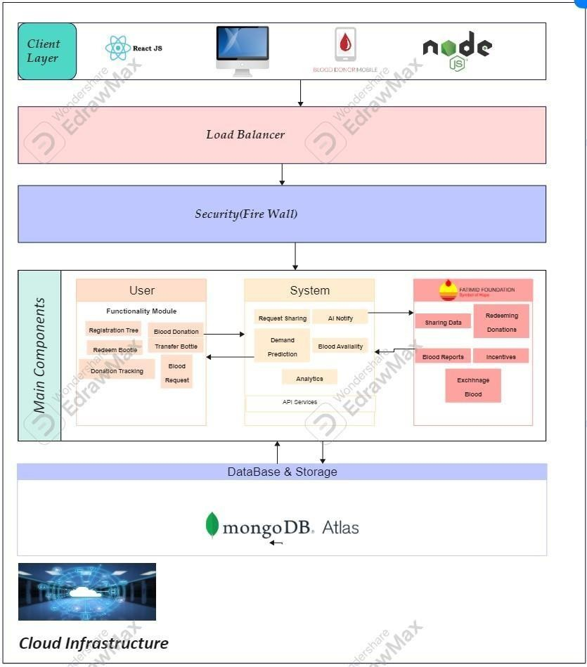

Final Deliverables of Project:

The Blood Safe LIFE project will create a secure, web-based application aimed at streamlining blood donation and connecting donors,

receptors and platelets. The following are the final products of the project.

**Fully Functional Web-Based Blood Donation Platform**

A responsive and user-friendly web application will be developed, accessible on various devices, including desktops, tablets, and smartphones. The platform will serve as the central hub for all users, including donors, recipients, and blood banks. Key features of the platform will include:

* + **User Registration and Profile Management**:
  + **Real-Time Blood Requests and Notifications**:
  + **Blood Redemption and Transfer System**:
  + **Donor Blood Tracking**:
  + **Blood Bank Locator**:

1. **Secure Data Management and Privacy Protection**

The platform will include robust data security measures, ensuring that all user information (personal details, medical data, and donation history) is encrypted and protected. The privacy of donors and recipients will be maintained through anonymization, and all transactions will be traceable without compromising sensitive information.

1. **Incentive and Loyalty Program**

A fully functional reward system for loyal donors will be implemented. The program will include features such as:

* + **Donor Incentives**: Rewards such as certificates, discounts, or other benefits for regular donors.
  + **Referral Program**: A referral system to encourage users to bring in new donors by offering rewards for successful referrals.

1. **Integration with Existing Blood Banks and Hospitals**
   * The platform will integrate with various blood banks and hospitals, allowing real-time updates on blood availability
2. **Educational Resources and Awareness Campaigns**
   * The platform will host educational materials and awareness campaigns to encourage blood donations.
3. **Comprehensive Admin Panel for Blood Banks**
   * A back-end admin dashboard will be provided for blood banks and hospitals to manage blood donations, stock updates, donor records, and requests. This panel will include:
4. **Comprehensive Testing and Documentation**

* The final deliverables will also include a complete suite of tests for system functionality, usability, security, and performance.

# Core Industry

Blood Banks & Hospitals

# Core Technology:

* + **Frontend** (HTML, CSS, React JS)
  + **Backend** (Node JS, Express JS, Python)
  + **Database** (MongoDB)
  + **APIs**: To be Decided

|  |  |  |
| --- | --- | --- |
| References  Project Key Milestones | | |
| **Elapsed time in (days or weeks or month or quarter) since start of the project** | **Milestone** | **Deliverable** |
| Month 1 |  |  |
| Month 2 |  |  |
| Month 3 |  |  |
| Month 4 |  |  |
| Month 5 |  |  |
| Month 6 |  |  |
| Month 7 |  |  |
| Month 8 |  |  |

# Project Equipment Details



|  |  |  |  |  |
| --- | --- | --- | --- | --- |
| **Item(s) Name** | **Type** | **No. of Units** | **Per Unit Cost (in Rs)** | **Total (in Rs)** |
|  |  |  |  |  |
|  |  |  |  |  |
|  |  |  |  |  |
|  |  |  |  |  |
|  |  |  |  |  |
|  |  |  | **Total in (Rs)** |  |

